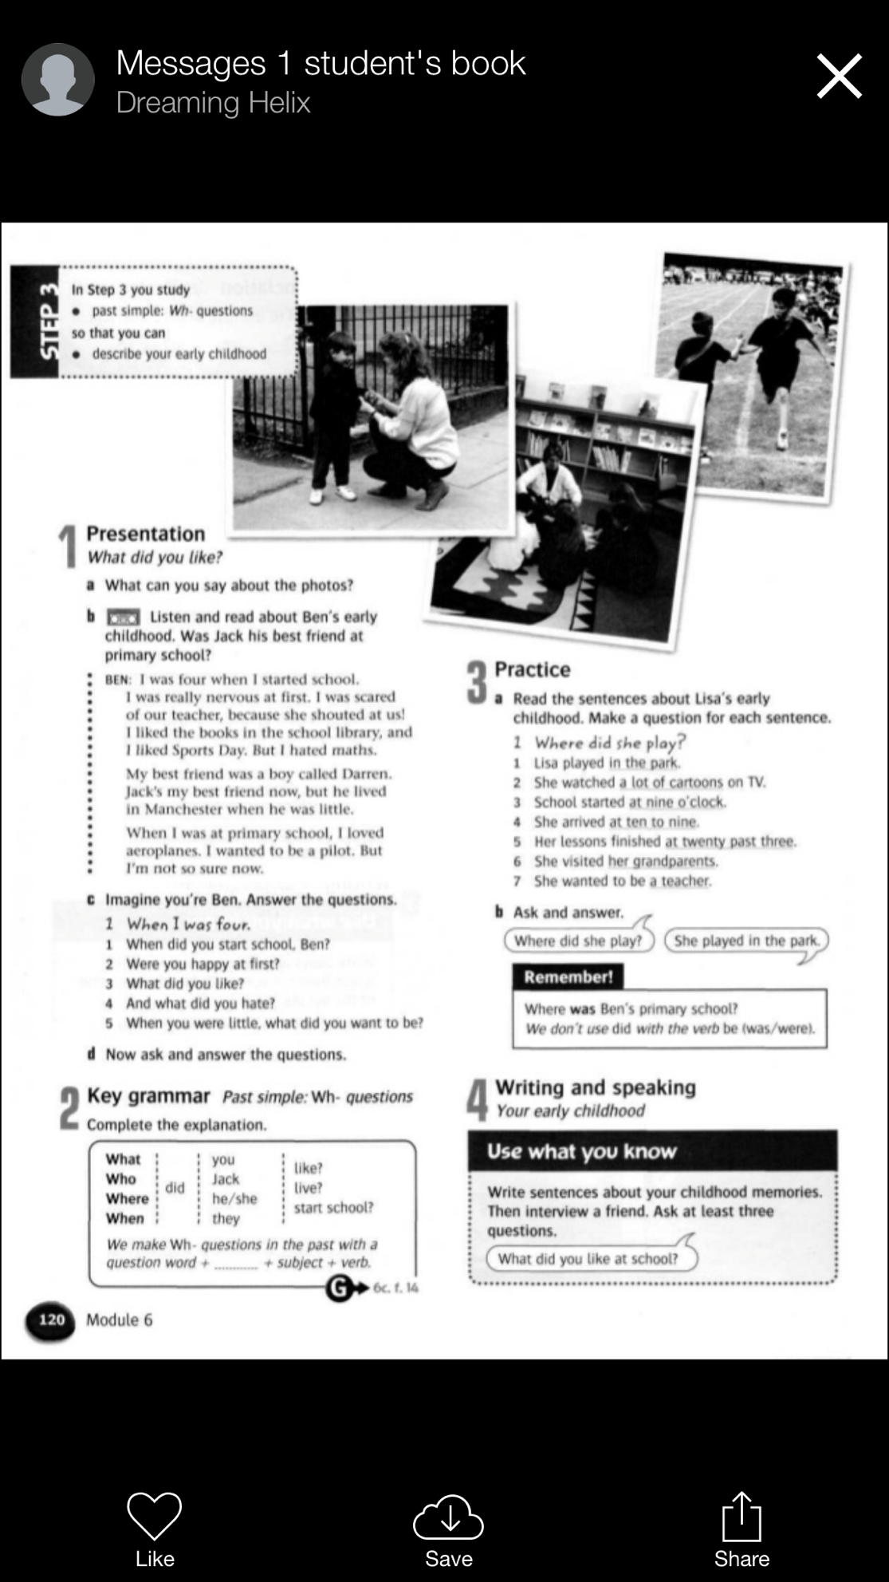
Grammar-Past simple:Wh-questions

